**Managing Users and Groups**

## Accessing the AWS Management Console

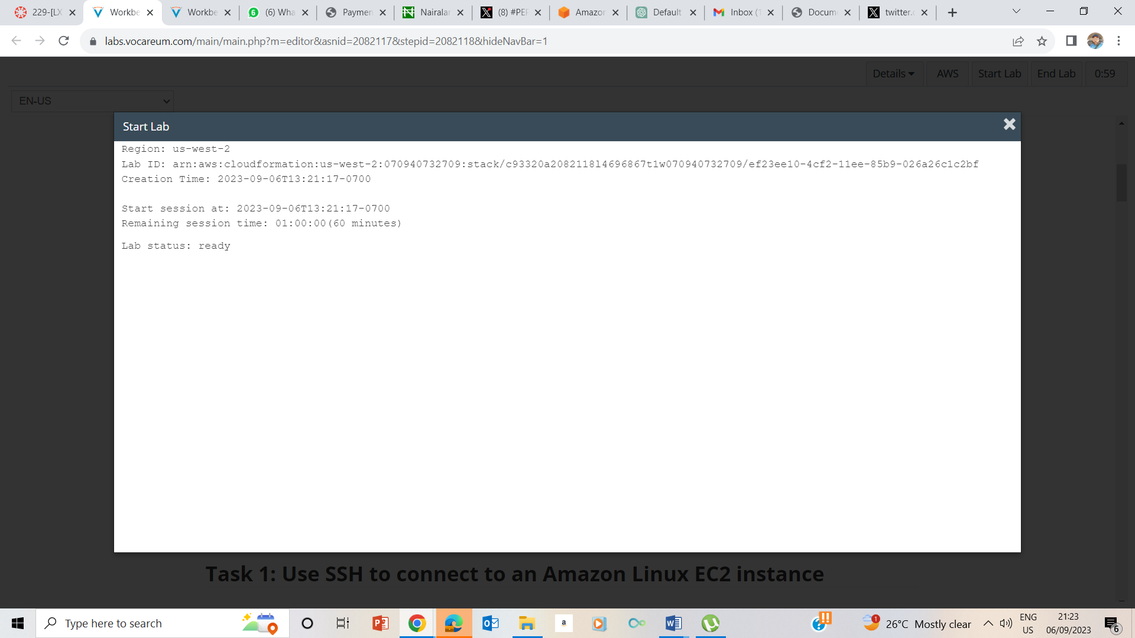

## Accessing the AWS Management Console

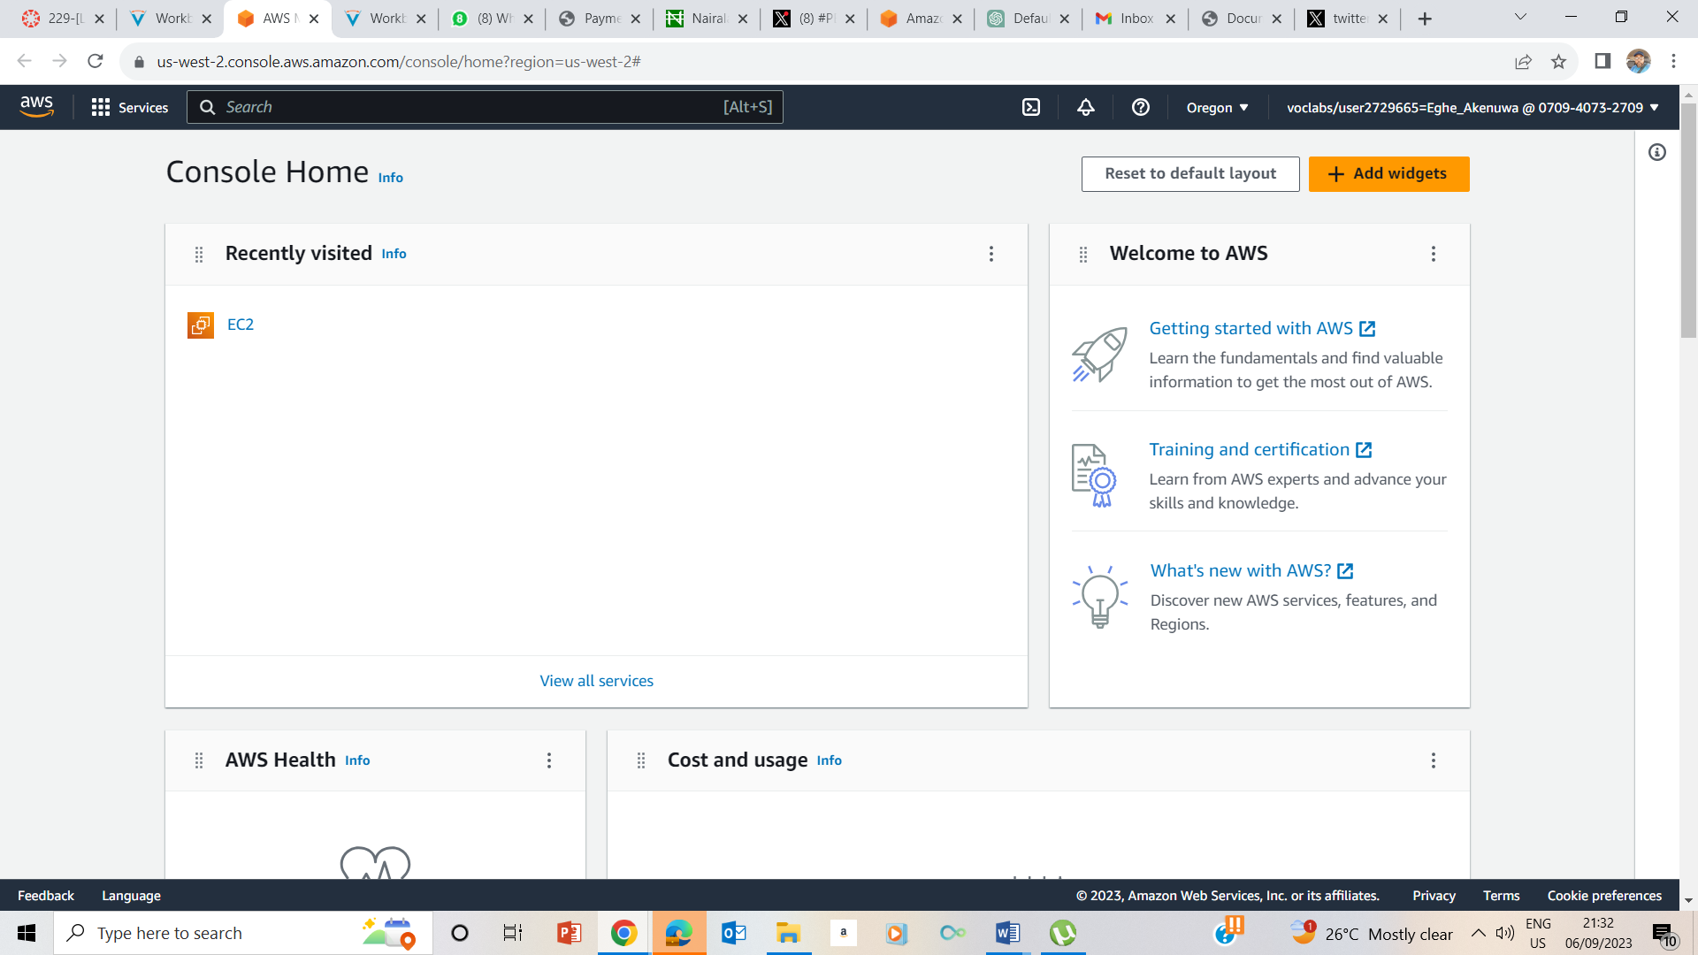

## Task 1: Use SSH to connect to an Amazon Linux EC2 instance

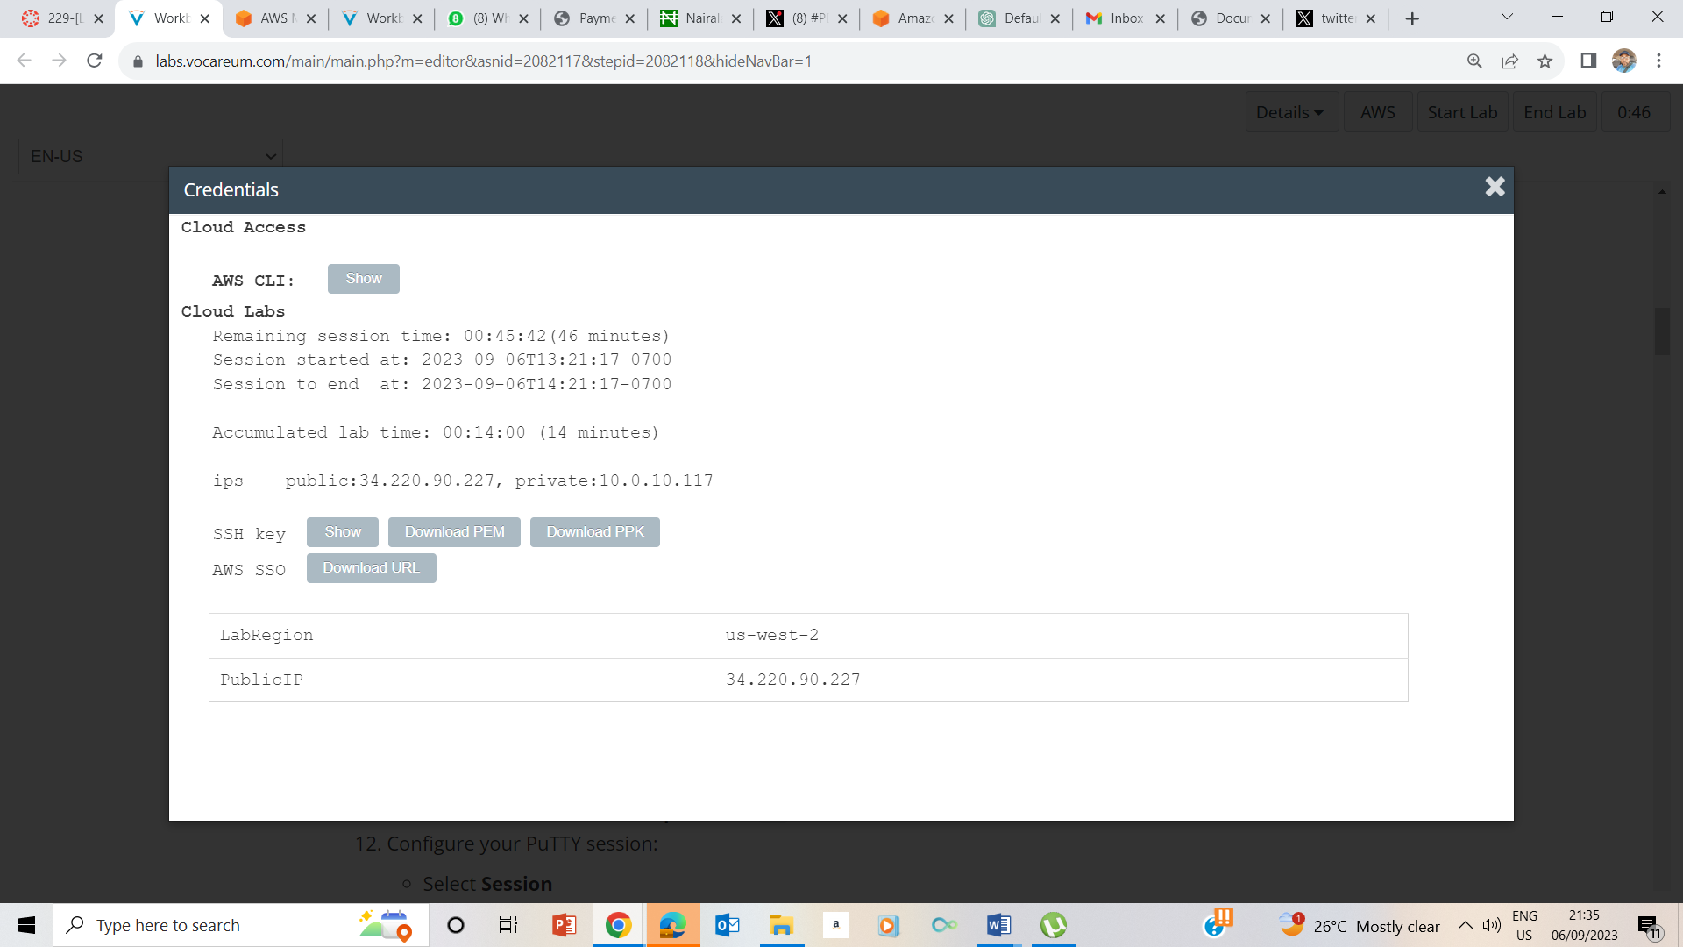

Clicked on the Details drop down box, selected show and on the credentials page, I downloaded PPK file, and noted the Publicip address .

13

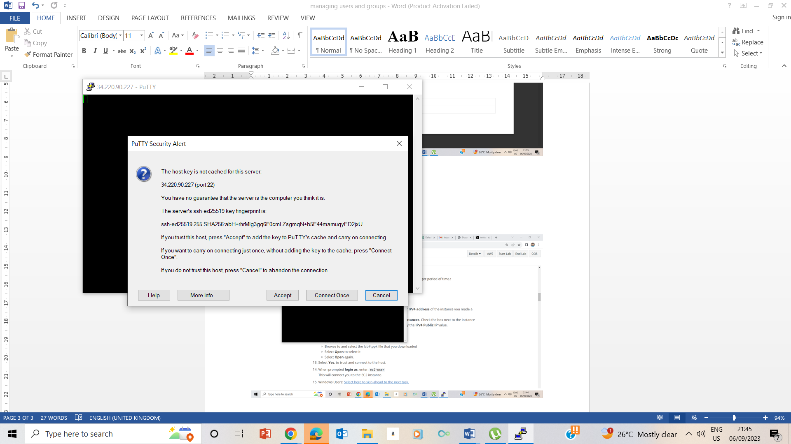

Downloaded putty file, ran putty.exe and also configured it as in previous labs, clicked on accept to trust it and get connected

12-14

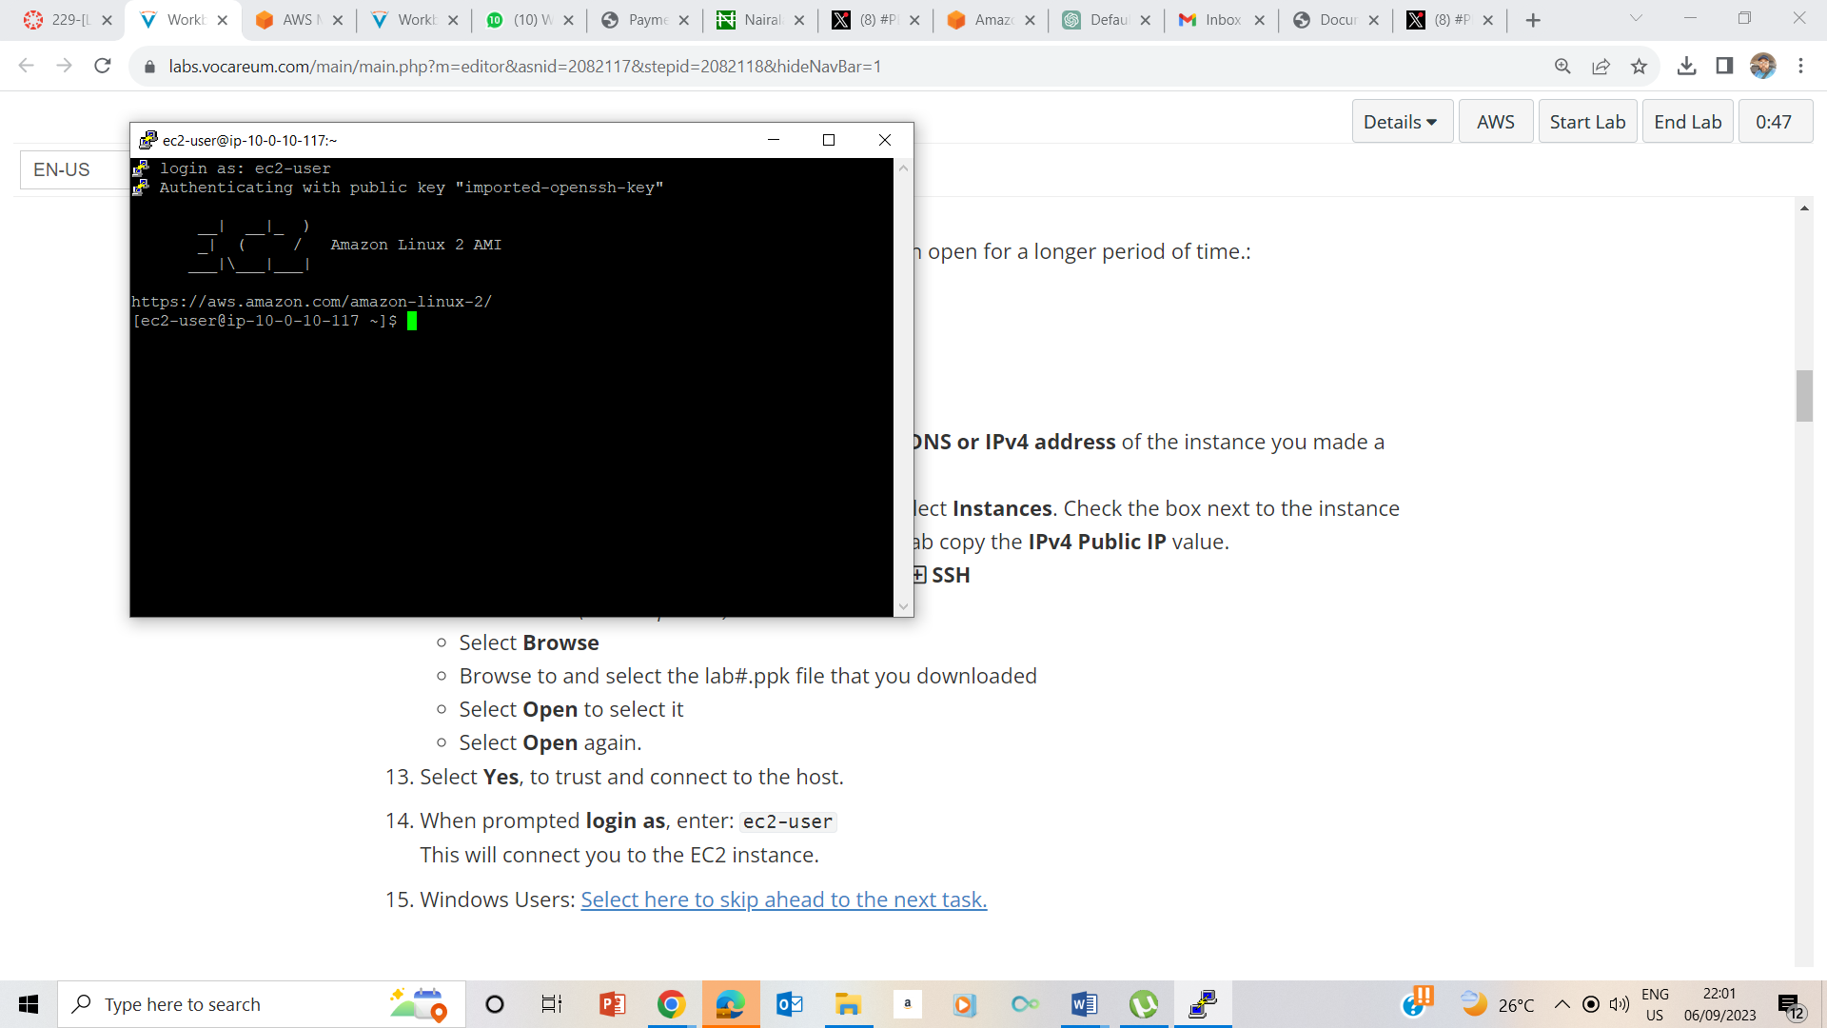

The putty is connected.

## Task 2: Create Users

24

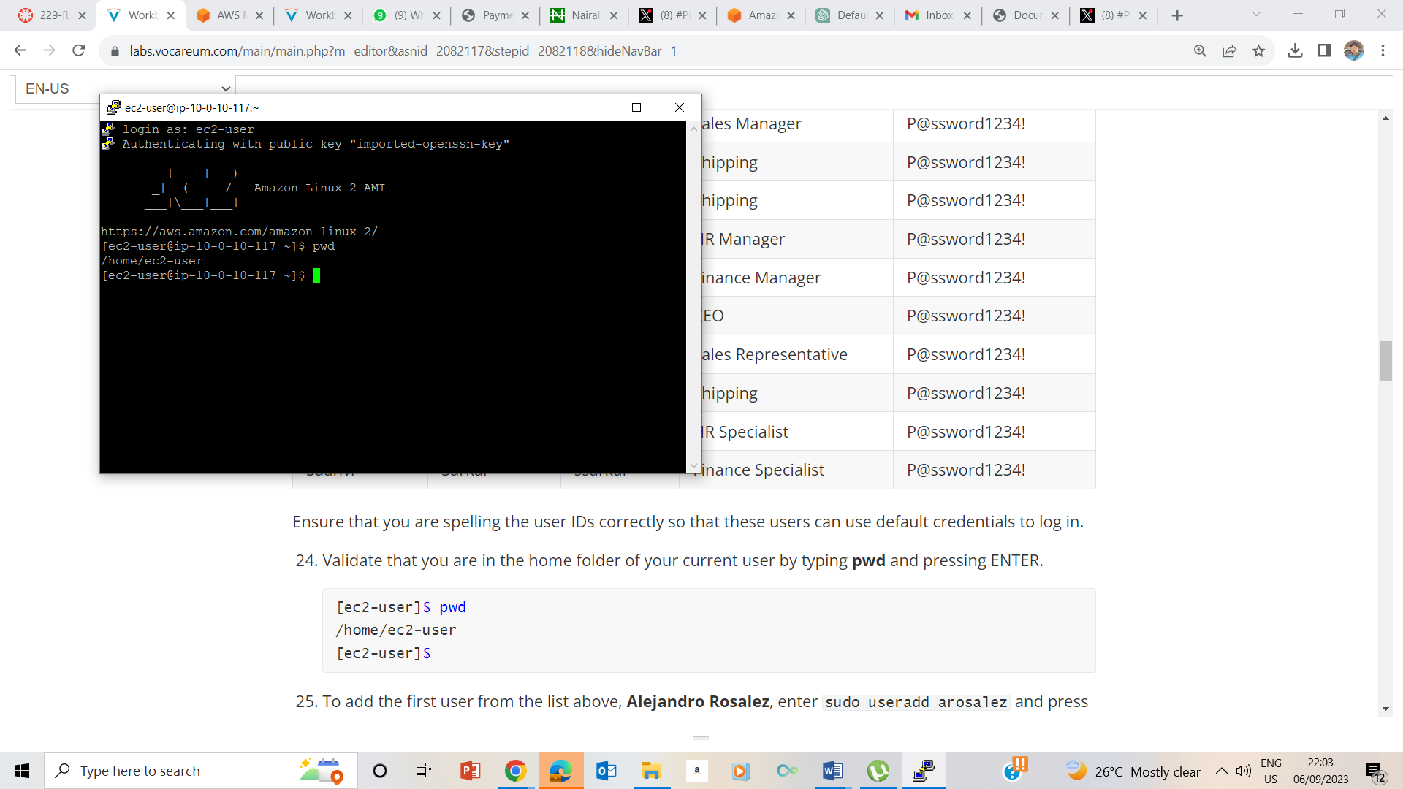

Entered pwd confirm my current folder

25-26

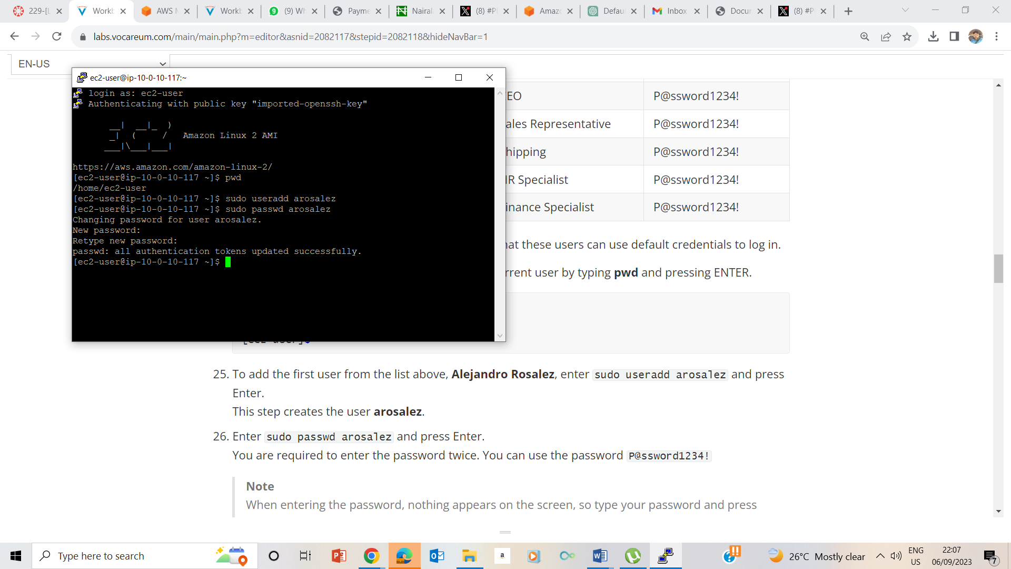

Created a user arosalez with added password

27-33

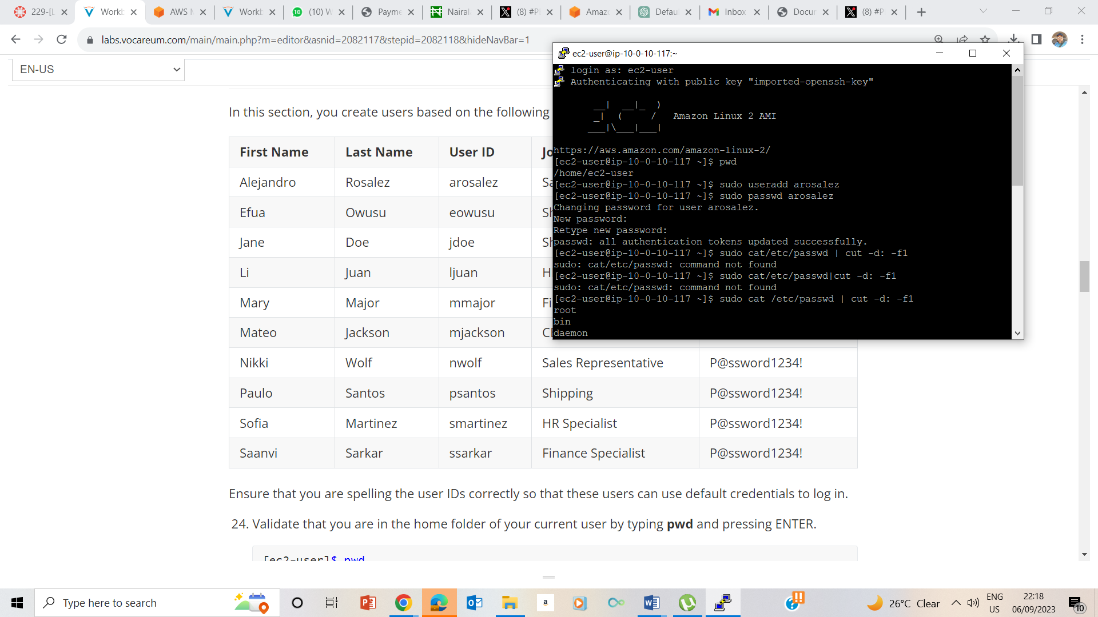

28

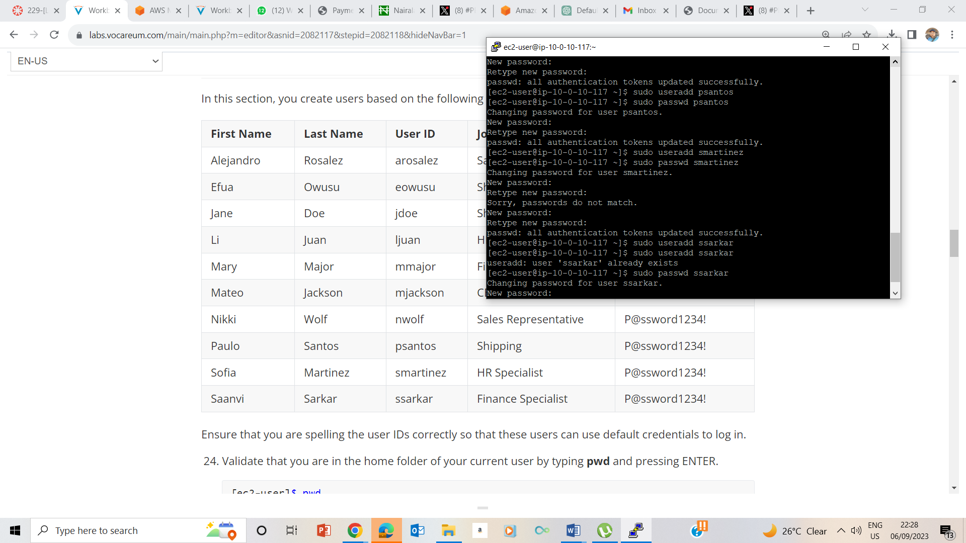

29

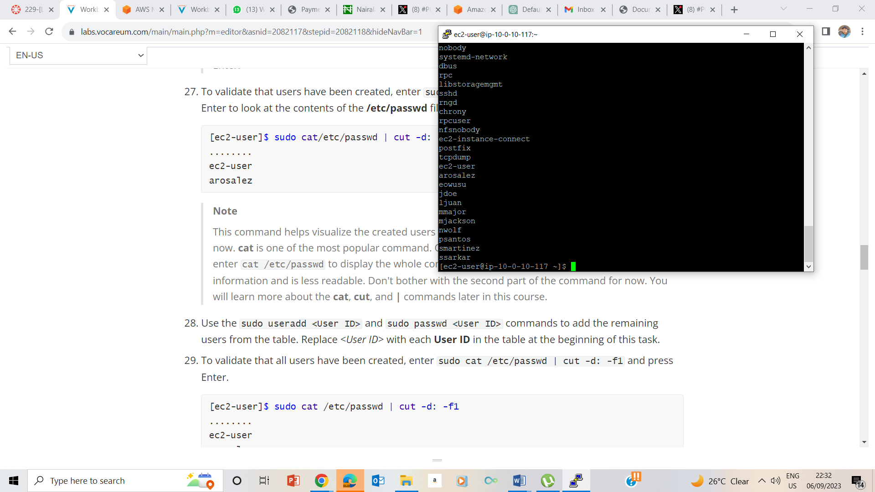

Used cat /etc/passwd | cut –d: -f1 to list all users created

## Task 3: Create Groups

30

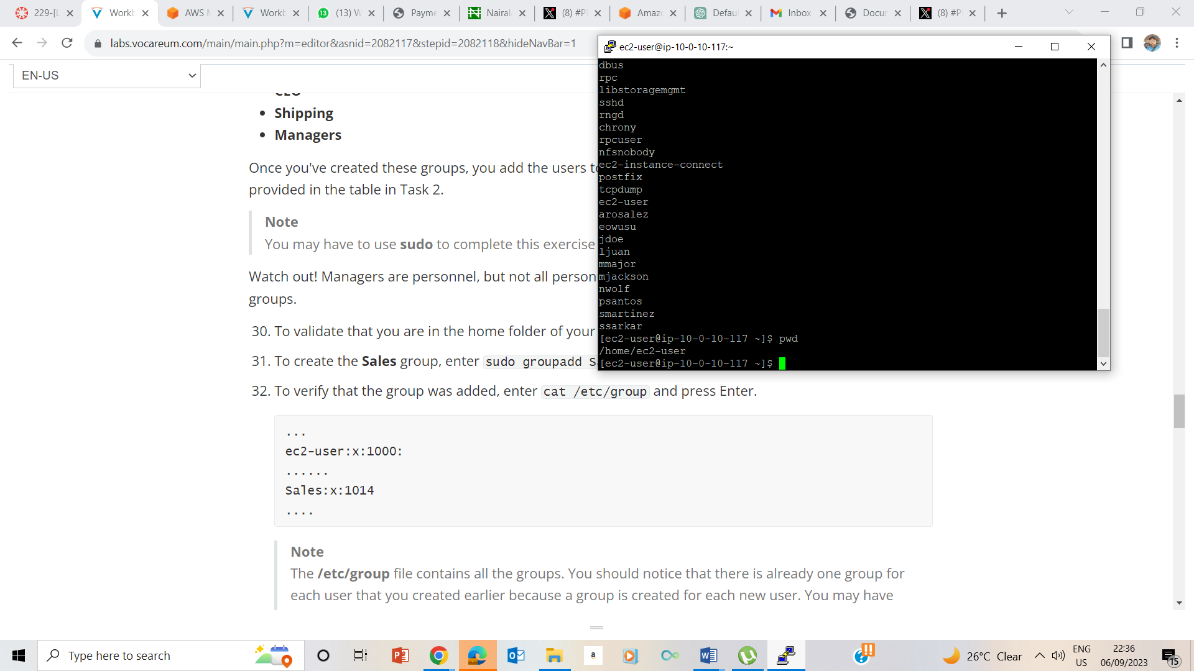

Pwd confirms my current folder

31

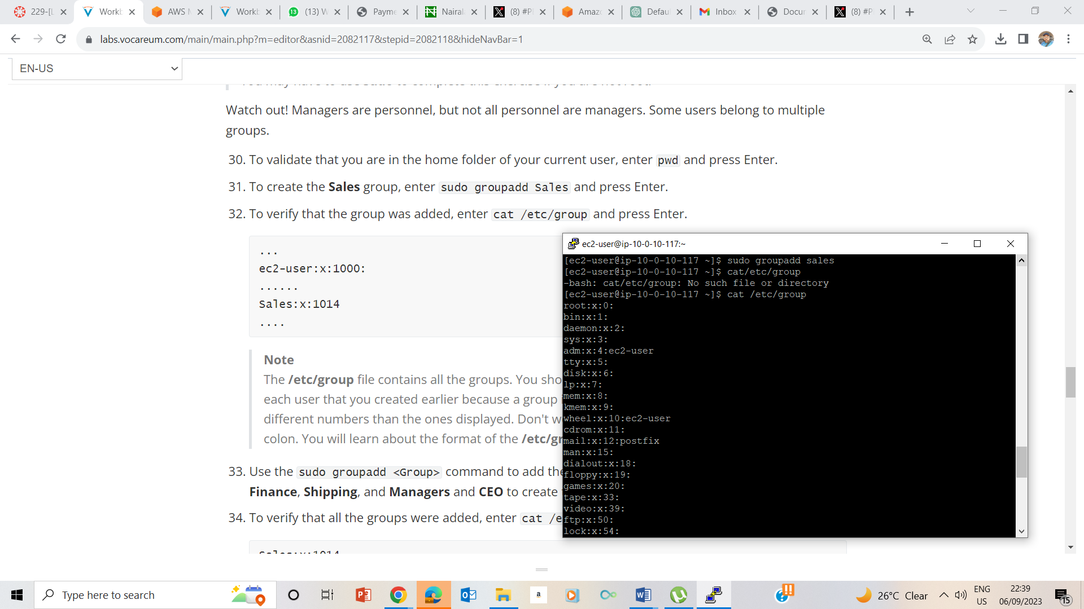

sudo groupadd Sales creates Sales group

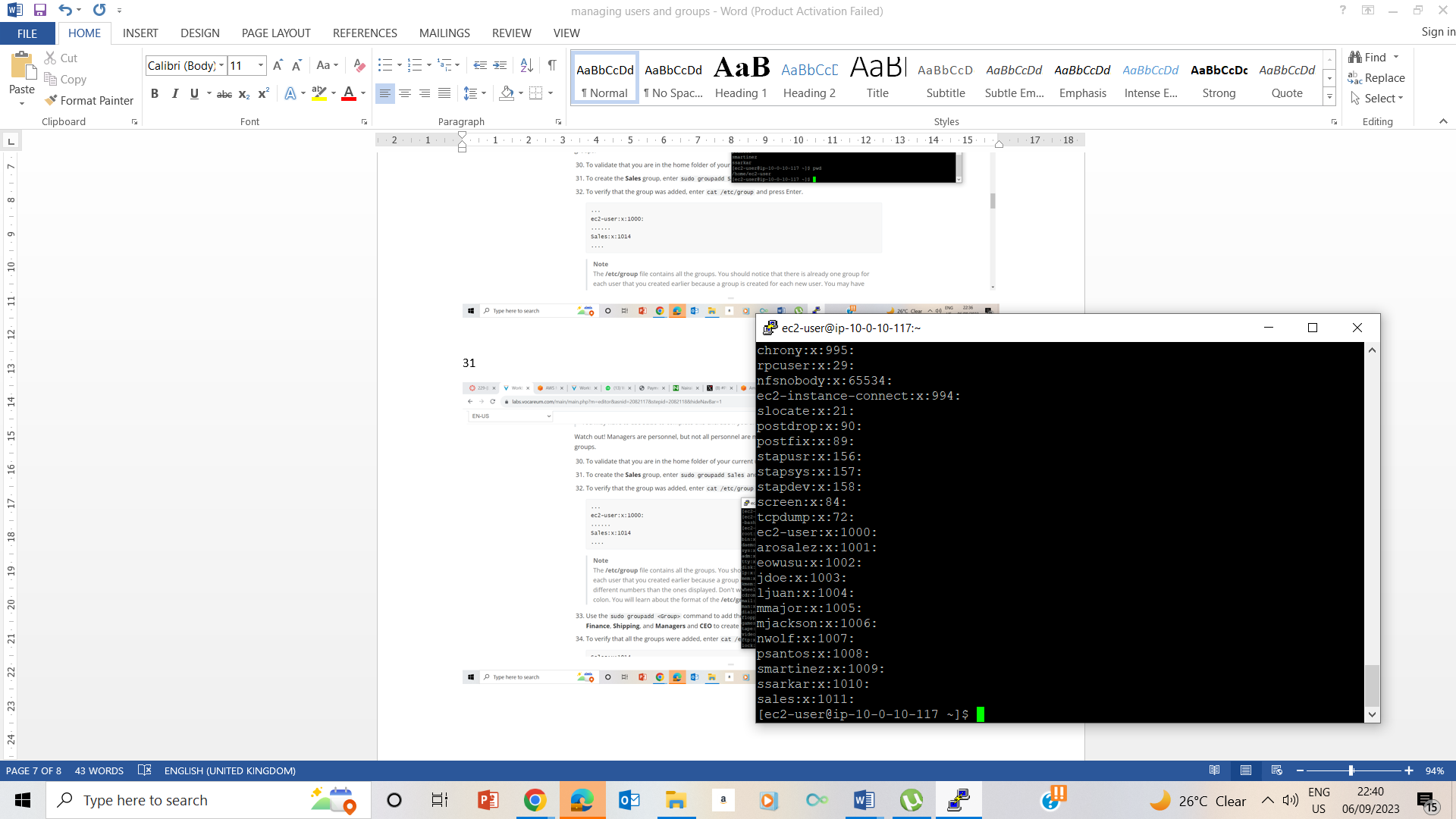

Cat /etc/group

32-34

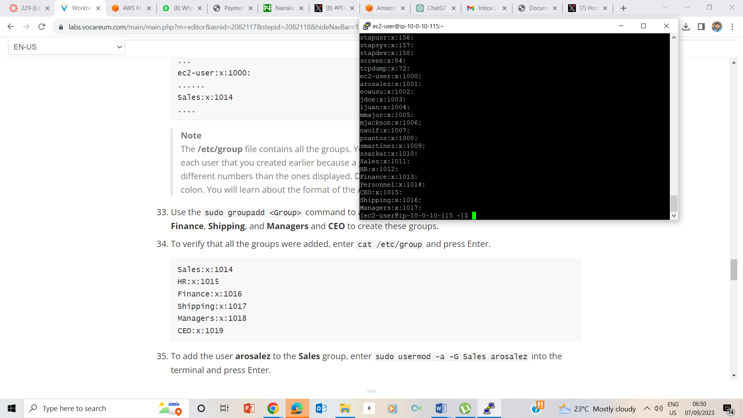

Cat /etc/group is used to verify that a group was created.

35 Added arosalez to Sales Group using sudo usermod –a –G Sales arosalez

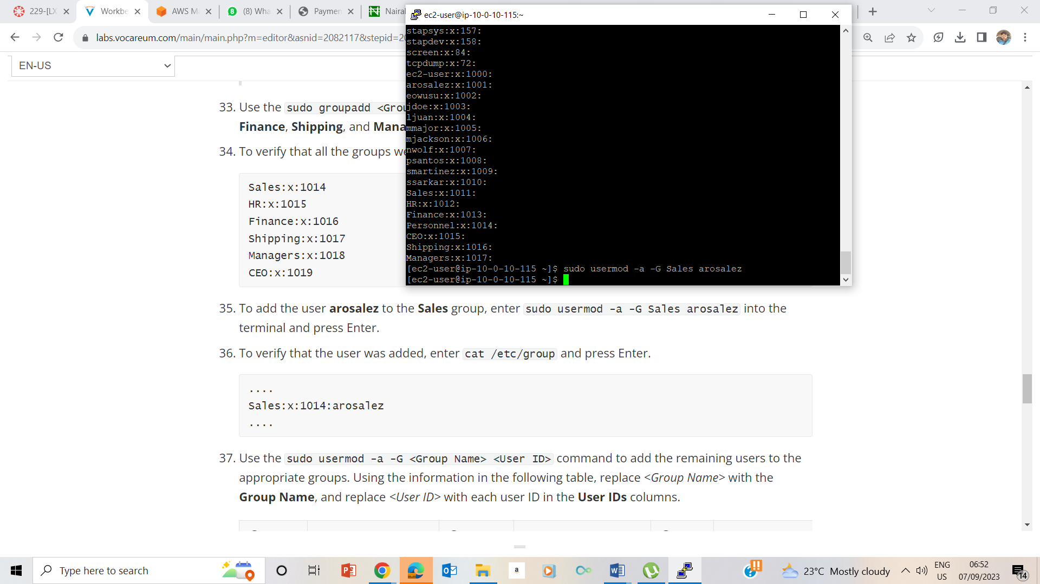

36. VERIFYING arosalez is in Sales group

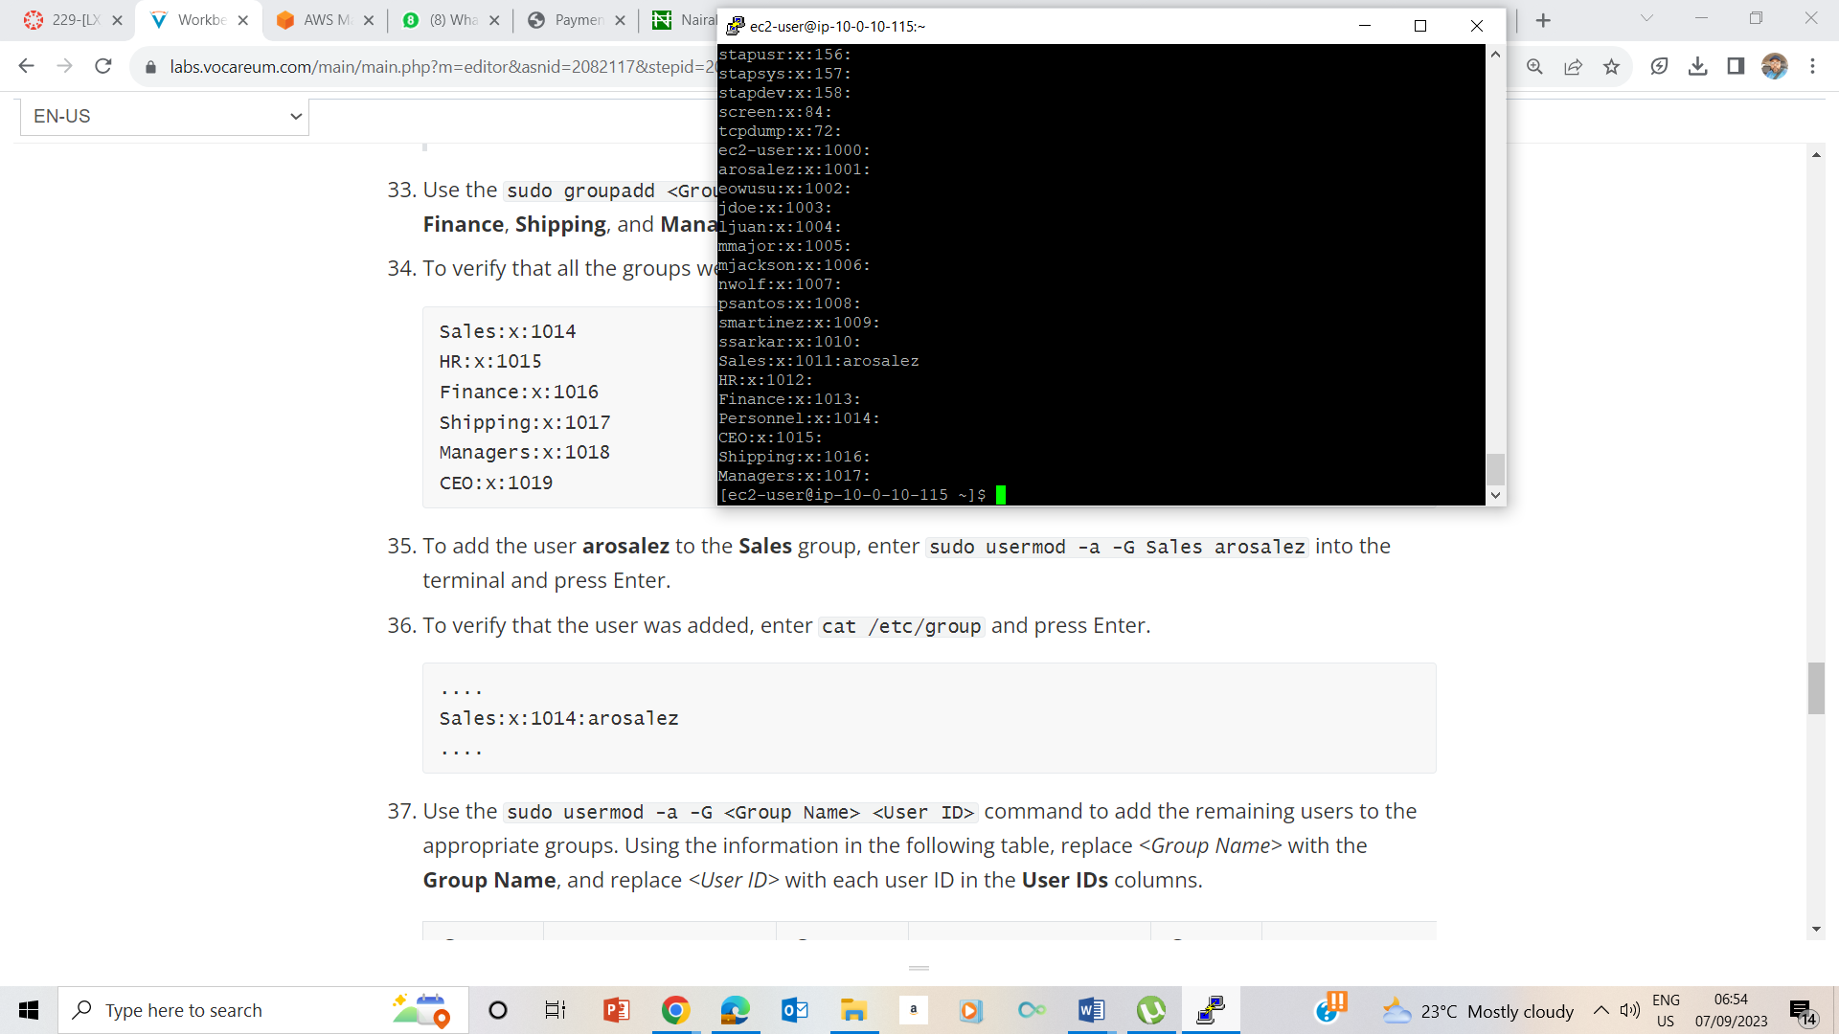

37 -42 Adding to Groups

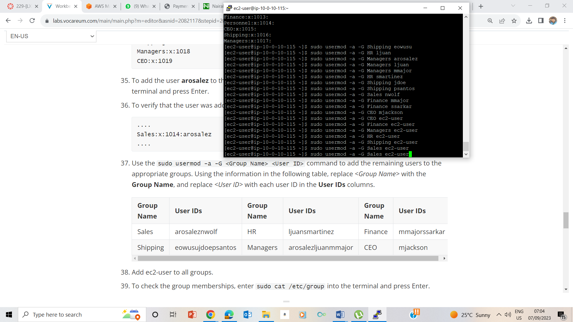

39. Confirming Group membership status using sudo cat /etc/group

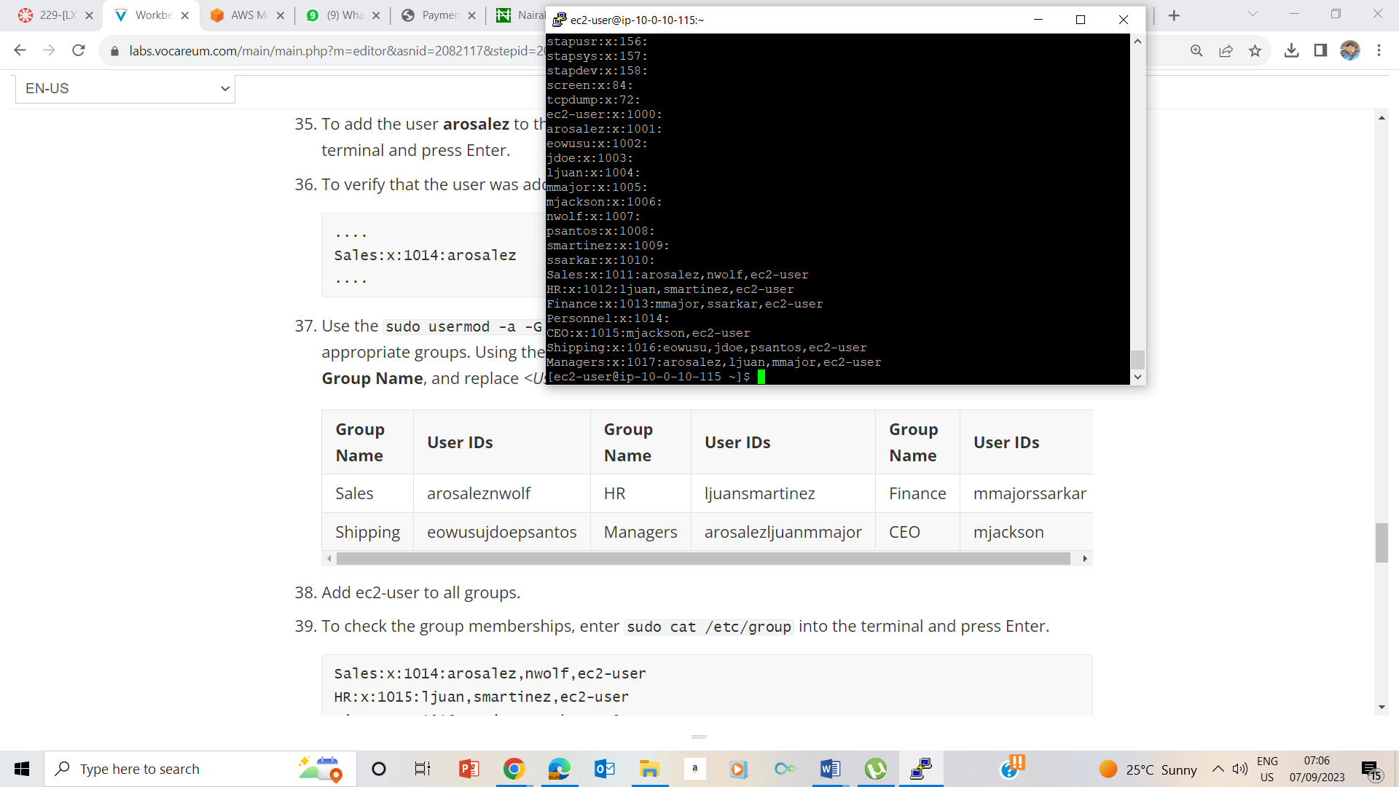

## Task 4: Log in using the new users

40-41

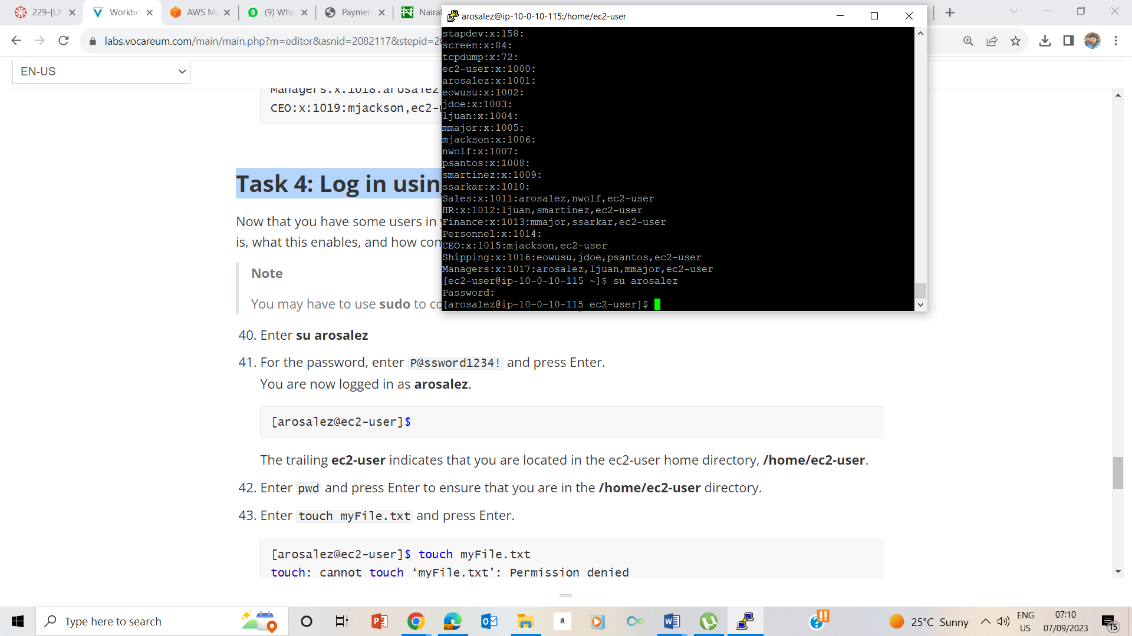

42 Home Directory using pwd

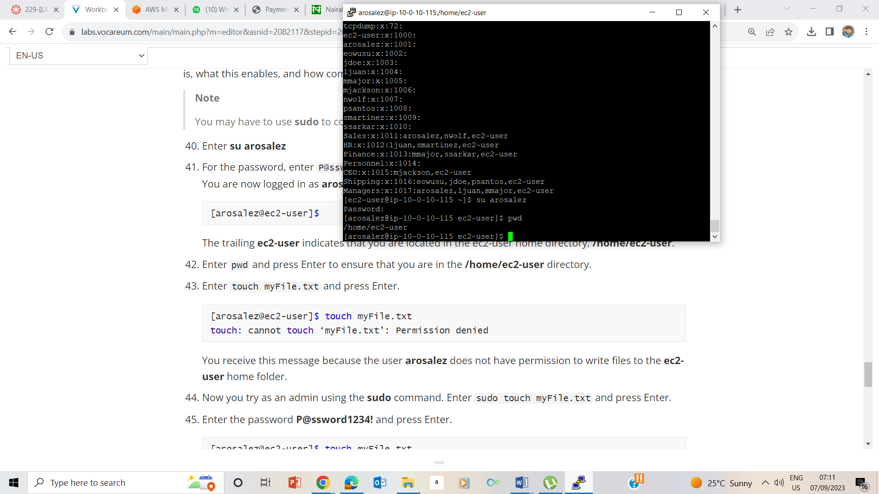

43 touch myfile.txt- permission denied

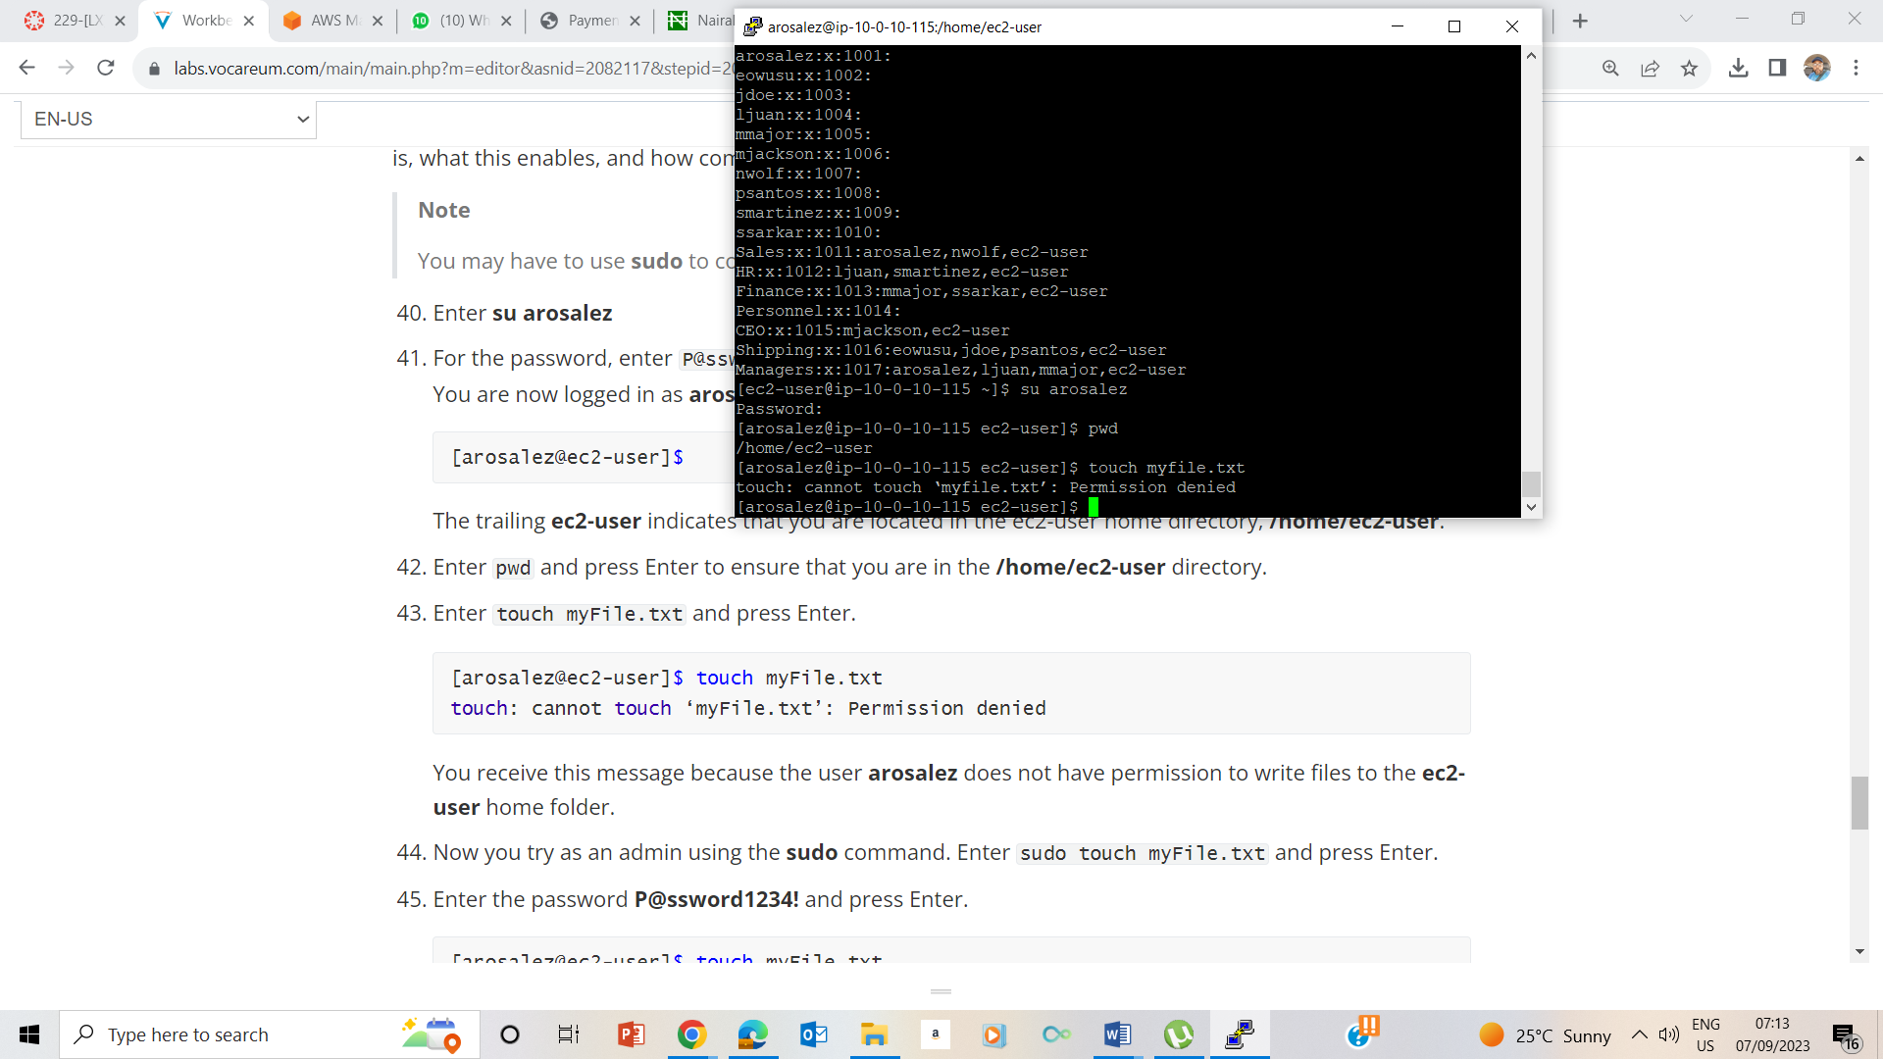

44.sudo using arosalez

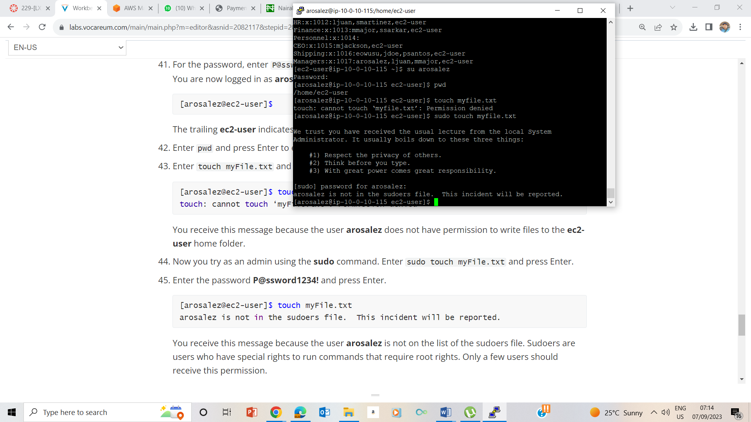

46. Report Log

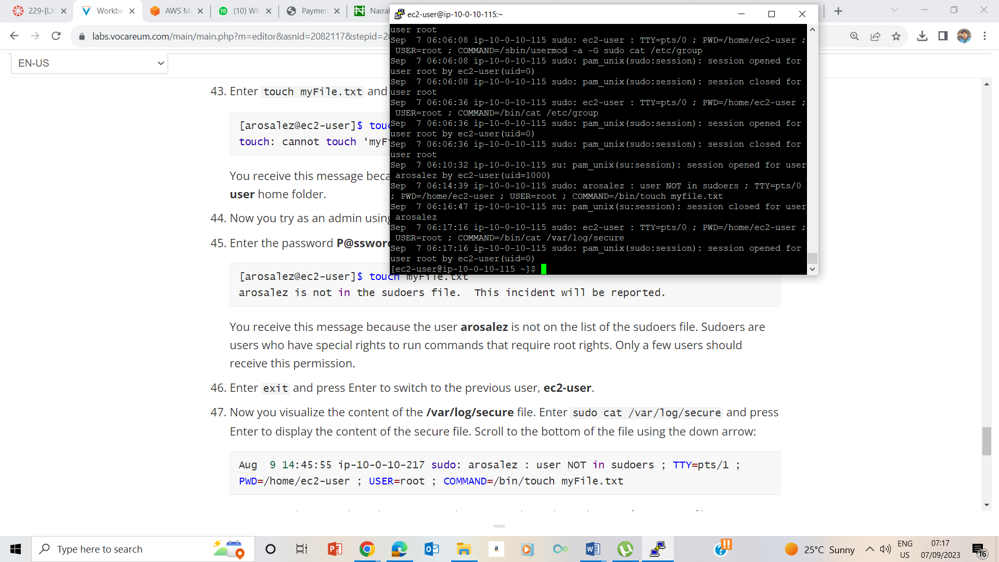

## Lab Complete